Journal of the Georgian Geophysical Society, ISSN: 1512-1127
Physics of Solid Earth, Atmosphere, Ocean and Space Plasma, v.22(2), 2019,pp

Organization Stable isotope monitoring network on the territory of Georgia
¹Melikadze G. I., ¹Todadze M. Sh., ¹Tchankvetadze A. Sh., ¹Gventsadze A. I., ²Chitanava R. I., ²Gafrindashvili M. I.
¹M. Nodia Institute of Geophysics, Ivane Javakhishvili Tbilisi State University, melikadze@gmail.com
²National Environmental Agency of Ministry Environmental protection and Agriculture
Abstract
Application of environmental tracers was using in the assessment of water resources and their vulnerability will be elaborated. Was starting organization monitoring network for study spatial-temporal variation of stable isotope on the territory of Georgia

Keywords: Stable isotopes, Monitoring network, Seasonal variation

Introduction
Climate projections for Georgia predict changes in precipitation and temperature patterns that would lead to prolonged dry periods and reduction of groundwater recharge. Precipitation has already decreased in some regions, which caused significant decrease and, in some places, even drying of the rivers and depletion of the natural springs. Significant decrease of groundwater tables resulted in the exhaustion of the soil, activation of the wind erosion and reduction of areas covered by vegetation (including pastures). Hence, there is a distinct tendency of processes actively leading to desertification.
Better understanding of the groundwater regime, interactions between surface waters and groundwaters and factors influencing groundwater quantity and quality is therefore of the utmost importance to secure the water supply for the economy and population. Improved knowledge of groundwater recharge is needed to avoid overexploitation of the resources and deterioration of current situation. Mapping of isotopic and geochemical tracers over the country would provide the essential information which is currently not available in Georgia and expand the opportunities for both research and practical recommendations related to the hydrological cycle and water management. Stable and radioactive isotopes (18O, 2H, 3H) of the water molecule provide the information which may otherwise be difficult or impossible to obtain, e.g. example on the time spent by the water in an aquifer, altitude of groundwater recharge area, contribution of river or snowmelt waters to the production wells, or identification of old waters recharged during other climatic conditions (1-5).
Material and methods
The project of Georgian Scientific foundation FR-18-10092 "Mapping environmental tracers for the assessment of water resources in Georgia under Changing Climatic Conditions" consists in the regional application of isotopic and hydrochemical methods for a better understanding of groundwater resources and links among groundwater’s, surface waters and pollution sources
The main aim of the project is Analysis of spatial and temporal distribution of isotopic and geochemical composition of natural waters in Georgia, identification of perspective water resources and their potential vulnerability. Organize new and use of existing for determining the background and character of variations isotopic and geochemical composition.
In the frame of project, during 2019, the temporal (monthly) sample collection for isotopic analyses carried out in the existing networks of Geological Hydrometeological Departments of National Environmental Agency (NEA) of Ministry of Environmental protection and Agriculture. Their network consist 8 GNIP (Global Network of Isotopes in Precipitation) and 4 GNIR (Global Network of Isotopes in Rivers) stations. Furthermore, monitoring network that includes 34 boreholes and 6 springs. Supplementary data hydrological and meteorological data from the existing networks (e.g. precipitation amount, air temperature, river discharge, results of chemical and isotopic analyses, water conductivity and pH) will be used too. Based on the existed agreement between mentioned above organization and Institute of Geophysics, carry out sampling for isotope by NEA, which will be carried out for analysis in the Institute of Geophysics. Besides, in the monitoring network included the deep aquifers monitoring network (www.hggrc.net) of Institute of Geophysics, which covered all the territory of Georgia and where carried out monthly sampling campaign for chemical and isotope analysis. The existing and newly obtained data are using for assessment temporal variation of stable isotopes and geochemical parameters (background, seasonal variation etc).

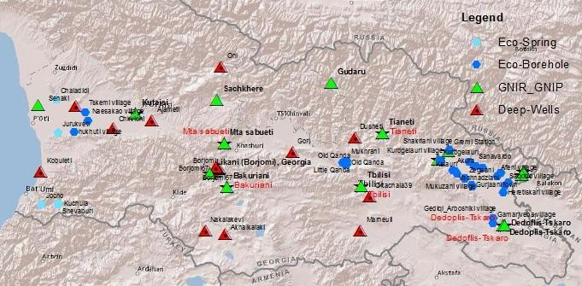

Fig 1 Location of monitoring station on the territory of Georgia

Environmental isotopic (¹⁸O and ²H) analysed and interpreted in the Institute of Geophysics.
In order to assessment spatial-temporal variation of stable isotope data analyzed undependably for precipitation, surface, groundwater and together.

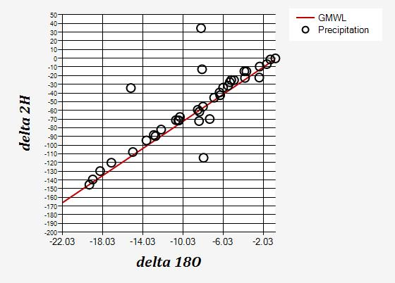
Fig. 2. Variation of isotopes in precipitation.

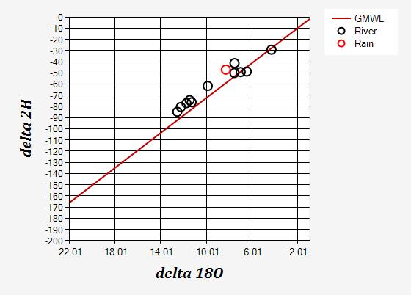
Fig. 3. Variation of isotopes in rivers and precipitation.

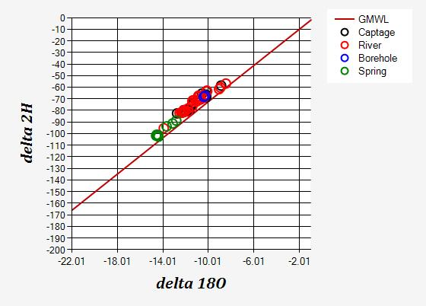
Fig. 4. Variation of isotopes in surface and groundwater.

On the all figures shows the ¹⁸O-²H relationship. It reveals that waters in almost all samples are located along the global meteoric water line. Value of stable isotopes are mainly changing according elevation and became heavier along his pathway. Fig. 2 reveals that on the value of modern precipitation influences difference between elevation of station and seasonal variation. Its value changed between large amount -2.3 – 18.3 ‰ V-SMOW. Fig. 3 shows, that value of δ¹⁸O isotopes in river is heavier -6.1 ‰ V-SMOW (compare with same period of sampling the precipitation) and variation has “narrower” diapason. Fig. 4 show value of all kind water source water (precipitation. spring, river and borehole). Because, generally all station contains fresh water, that why isotope value located nearby each other along GMWL. Pathway from precipitation to surface water (river) shorter, than to the groundwater (spring and borehole). That why spring water δ¹⁸O value heavier (-14.1- -12.13 ‰ V-SMOW) tan rivers ((-12.1- -10.01 ‰ V-SMOW).

Conclusions
Isotopic composition of water in the study area evolves according to a line parallel with the global meteoric water line. Studded average value of stable isotope (¹⁸O-²H) and its relationship. Fixed isotope value in difference water source (precipitation, surface and groundwater) and following evolution of groundwater isotopic composition in the space (pathway from recharge to the discharge area) and temporal (seasonal variation) variation .

References
- Melikadze G., Chelidze T. , Zhukova N., Rozanski K., Dulinski M., Vitvar T. (2009). Using nuclear technology for environmental safety and sustainable development of water resources in Borjomi region (Southern Georgia). Journal of Georgian Geophysical Society, Issue (A), Physics of Solid Earth 13a, 17-25.
- Melikadze G., Chelidze T., Jukova N., Malik P., Vitvar T. (2011). Using Numerical Modeling for Assessment of Pollution Probability of Drinking Water Resources in Borjomi Region (Southern Georgia). In: Climate Change and its Effects on Water Resources, Issues of National and Global Security (Baba A., Tayfur G., Gunduz O., Howard K.W.F., Fridel M.J., Chambel A., eds.), NATO Science Series. Springer. ISBN:978-94-007-1145-7. Chapter 29, 267-275.
- Vitvar, T, Aggarwal, P.K.,Herczeg, A.L.(2007). Global Network is launched to monitor isotopes in rivers. EosTrans. AGU 88:325–326.
- Melikadze G, at al., Preliminary result of stable isotopes monitoring in the Alazani-Iori catchment , Journal of Georgian Geophysical Society, Issue (A), Physics of Solid Earth, v.17a, 2014, pp. 39-46
- G. Melikadze, N. Zhukova, M. Todadze, S. Vepkhvadze, T. Vitvar. "Result of numerical modelling of groundwater resource in the Shiraki catchment”. Journal of Georgian Geophysical Society 01/2014; Physics of Solid Earth, v. 17a (Issue (A)):102-108.

Acknowledgments: The authors thank the Rustaveli National Scientific foundation for financial support of the project #FR-18-18-10092 "Mapping environmental tracers for the assessment of water resources in Georgia under Changing Climatic Conditions".

სტაბილური იზოტოპების მონიტორინგული ქსელის ორგანიზება საქართველოს ტერიტორიაზე

მელიქაძე გ.ი., თოდაძე მ. შ., ჩანკვეტაძე ა. შ., გვენცაძე ა. ი., ჭითანავა რ. ი., გაფრინდაშვილი მ. ი.

რეზიუმე
მიწისქვეშა წყლების რესურსების შესწავლისა და მათი მოწყვლადობის შეფასებისთვის დაინერგა ეკოლოგიური ტრასერების მეთოდოლოგია. სტაბილური იზოტოპების დროით-სივრცული ცვლილებების შესწავლის მიზნით დაიწყო სამონიტორინგო ქსელის ორგანიზება საქართველოს ტერიტორიაზე.

Организация мониторинга стабильных изотопов на территорий Грузии

Меликадзе Г. И., Тодадзе М. Ш, Чанкветадзе А. Ш., Гвенцадзе А. И., Читанава Р. И., Гафриндашвили М. И.

Аннотация
С целью оценки ресурсов подземных вод и установления их екологической уязвимости было внедрено методика экологических трассеров. С целью изучения временно-пространственой изменямсти начато организация мониторингшовой сети на территорий Грузий.

