Journal of the Georgian Geophysical Society, ISSN: 1512-1127
Physics of Solid Earth, Atmosphere, Ocean and Space Plasma, v.22(2), 2019,pp

Chemical survey and reservoir temperature estimations of Tbilisi geothermal deposit by application of silica-enthalpy mixing method

¹Kapanadze N. A., ¹Melikadze G. I., ²Forizs I. V., ¹Vepkhvadze S.G, ¹Todadze ¹M. Sh. Chikviladze E. V., ¹Ghlonti L. E,

¹M. Nodia Institute of Geophysics, Ivane Javakhishvili Tbilisi State University, Tbilisi, GEORGIA
ninokapanadze@gmail.com
²Institute for Geological and Geochemical Research, Budapest, Hungary, forizs.istvan@csfk.mta.hu

Abstract: This study is the first attempt to use geochemical techniques to evaluate geothermal reservoir in Georgia. The geographical area of the study is named the Tbilisi geothermal reservoir and belongs to the Sartichala sub-zone of the Adjara-Trialeti folded system of the Lesser Caucasus. Thirteen thermal water samples were taken from existing thermal boreholes on the territory of Tbilisi, additionally one sample of river Legvtakhevi, to be used as cold water component for estimation of reservoir temperature. The samples revealed the majority have Na-K-HCO₃ composition compared to just few of them Na-K-Cl-SO₄ and Ca-Mg-SO₄-Cl. Water-type changes from bicarbonate to Sulfate-Chloride from the West to the East were also observed. Reservoir temperature estimations by silica-enthalpy method is 130 ºC, 163 ºC, 212 ºC.
The results of this and other current studies manifest the need for further researches and the steps and methodology thereof.

Keywords: Geochemistry, Geothermal reservoir, Geothermometers, Silica-Enthalpy mixing method

Introduction
The objective of this study is to investigate the geochemical characteristics of the thermal waters. For hydrogeochemical evaluation, the commonly used Durov and L-L diagrams approach has been used. In order to assess the maximum reservoir temperature, the silica-enthalpy mixing method was applied.

Field survey-sampling-analytical methods
A Total of 14 samples (Figure 1) were collected - 13 of them are from the thermal wells and one from the small river representative of the surface water in the central area, which may also feed thermal springs and represent one of the source the recharge area for them.
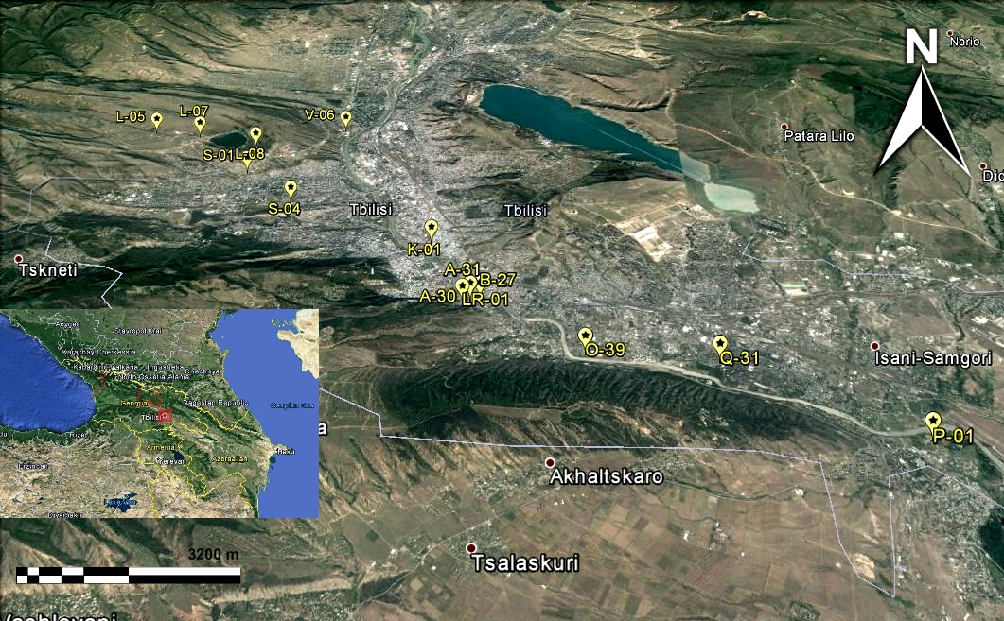
Figure 1. Location of study area and sampling points

All analyses were carried out at the chemical laboratory of the Research Center of Hydrogeophysics and Geothermy, M. Nodia Institute of Geophysics, Ivane Javakhishvili Tbilisi State University.
Unstable hydrochemical parameters, including temperature, pH and electrical conductivity (EC) were measured with portable field laboratory WTW 197i which was calibrated in the field prior to every sampling.
Physico-chemical data of the area were subjected to graphical treatment by plotting them in different diagrams using “Aquachem 5.1” software (Schlumberger water services) and graphing package “Grapher 10” (Goldensofware) in order to better understand the hydrochemical processes in the study area.

Major ions of Tbilisi thermal waters
Major ion composition and ionic ratios can act as a track-record of water-rock interaction during ascending flow. Durov (1948) diagram is based on the percentage of major ion milliequivalents. The values of cations and anions are plotted on two separate ternary diagrams and data points are projected onto square grid at the base of each triangle. The data are being presented using “Durov” diagram [1] (Figure 2), which illustrates some geochemical processes, which might affect the water genesis [2].
The Samples plotted on the Durov [1] diagram are located in the 3, 6, 9 and 5 zones [2]:
Zone (3): water is ion exchanged because HCO₃ and Na are dominants, although generation of CO₂ at depth can produce HCO₃ where Na is dominant.
Zone (6): water might be under influence of mixing. SO₄ is dominant or anion discriminant and Na dominant;
Zone (9): probably end-water type, Cl and Na dominant
Zone (5): water type exhibiting simple dissolution or mixing, no dominate anion or cation.
Figure 2. Durov (1948) diagram

For major cations and anions and geochemical processes, which might affect the genesis of Tbilisi thermal waters (Lioyd and Heathcoat 1985). Data points are being projected onto square grid in 4zones illustrating the patterns of thermal waters. Zone (3): water is ion exchanged because HCO₃ and Na are dominants, although generation CO₂ at depth can produce HCO₃ where Na is dominant.Zone (6): water might be under influence of mixing. SO₄ is dominant or anion discriminant and Na dominant; Zone (9): probably end-water type, Cl and Na dominant; Zone (5): water type exhibiting simple dissolution or mixing, no dominate anion or cation.
In order to evaluate the chemical evolution of Tbilisi thermal waters in the study area, the major ion chemistry was summarized in the form of the [3] L-L diagram. L-L diagram is a useful tool to see the patterns and correlations between the major cations and anions for multiple samples. Its square plot is similar to the projection areas of the Durov plot. L-L [3] diagram displays relative ratios instead of absolute concentrations.
The diagram shown in Figure 3, according which as it was expected, we can also identify 3 different chemical types of waters:
Group I, comprising 7 samples occupies the right lower part of the plot. In this group, waters are dominated by Na+K and HCO₃ and may, therefore, be designated as “Mixed alkali-bicarbonate type”.
Group II water samples (2 samples) have high concentration of Cl+ SO₄ and Na+K. This group may be named as “Alkaline-Chloride-Sulphate type”.
Group III water samples have the same high concentration of Cl+SO4 but higher Ca+Mg concentration than Group II waters. This group may be called as “Ca-Mg-Cl-SO₄ type”.
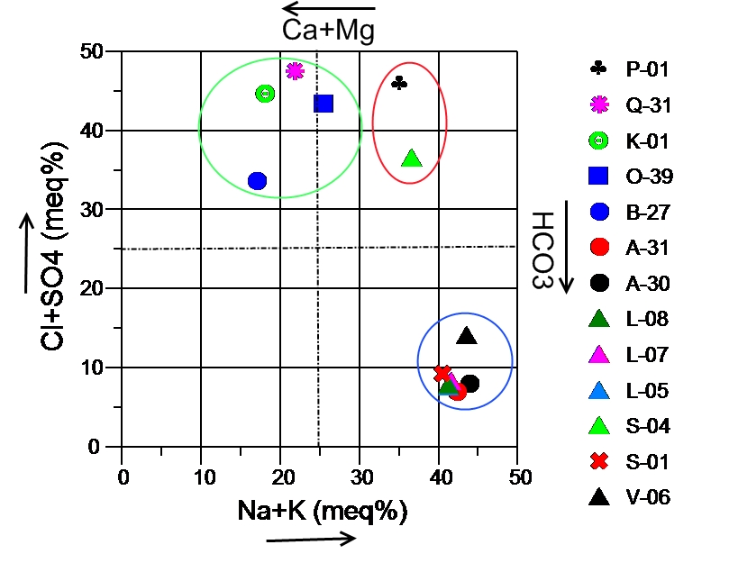
Figure 3. Langelier and Ludwig (L-L) (1942)

Diagram summarizing the major ion chemistry of Tbilisi thermal waters. In the figure can be identified 3 different types of water: Mixed alkali-bicarbonate type, Alkaline-Chloride-sulphate type and Ca-Mg-Cl-SO₄ type. In order to estimate the temperature for the Tbilisi mixed geothermal water, the silica-enthalpy mixing model [5] was used. Despite the fact that the mentioned model is based on the assumption that the silica deposition does not occur before or after mixing and that, that quartz controls the solubility of silica in the high-temperature waters, it, in many cases, gives good results for estimations of hot water component temperature.

Silica-enthalpy mixing method
Application of chemical geothermometers is a common practice to investigate the thermal state of geothermal reservoirs [4]. Geothermal water transfers heat to the contact rock while rising to the surface and they have lower temperatures than the reservoir. In order to investigate the thermal state of Tbilisi geothermal reservoir the chemical geothermometers , as a standard tool, were applied. The data of chemical analyses of water collected from the thermal boreholes and the SiO2 concentration in waters were used for subsurface temperature calculation by using silica-enthalpy mixing model.
The sample LR-01, having the minimum SiO₂ concentration and temperature, was used as the non- thermal component of the mixed waters. In Figure 4, 3 possible a, b and c mixing lines were drawn. If we assume that maximum steam loss occurs before mixing, the three lines drawn from the cold water component of the mixed water through the mixed thermal waters till the intersection with the vertical line drawn from the boiling (100 ºC) temperature - as a steam release temperature, will give 3 points A, C, E. And the intersections of drawn horizontal lines from these points to the quartz solubility curve (B, D and F) correspond to the maximum steam loss. The values of obtained points give the original silica concentration of the thermal water component. The values are about 130 ºC, 163 ºC, 212 ºC.

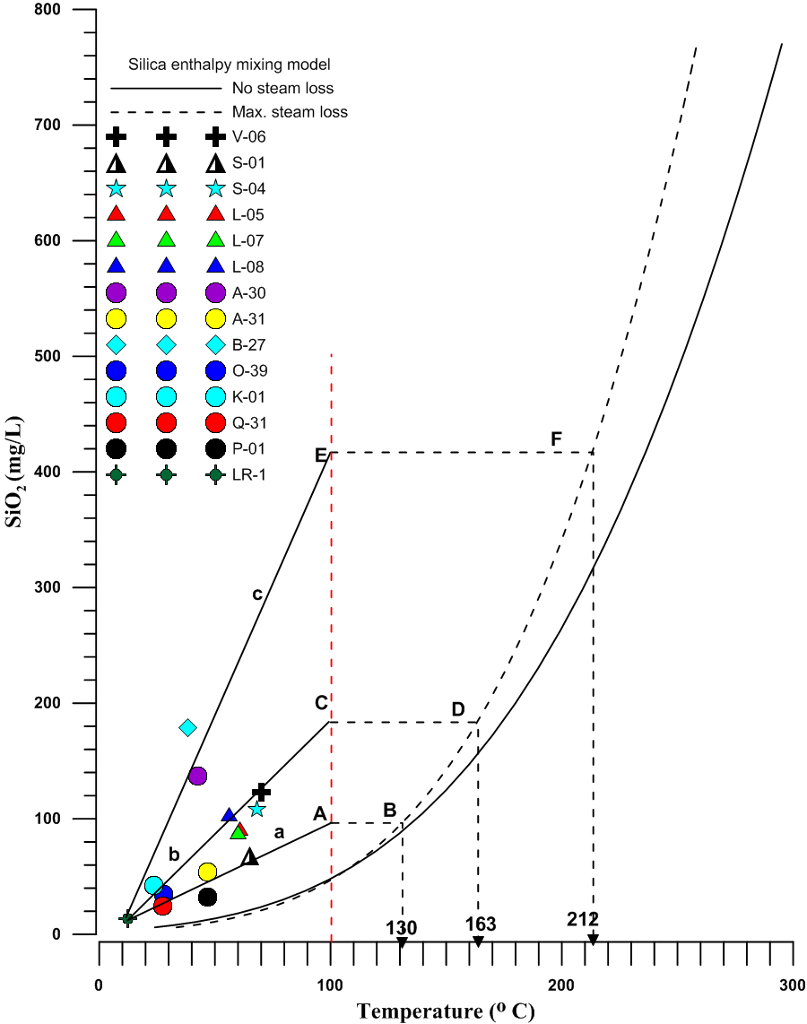
Figure 4. Silica enthalpy mixing model (Truesdell and Fournier, 1977).

LR-1 represents the Legvtakhevi river sample, which is used for non-thermal component. Sample IDs correspond to all tables and Figures

Conclusions
Deep thermal water migrating upward mixes with shallow groundwater system and changes its chemical properties. Thermal waters have mainly Na (K)-HCO₃, Na (K)-Cl-SO₄ and Ca (Mg)-Cl-SO₄ composition. In waters of Lisi-Saburtalo area the ion exchanges because HCO₃ and Na are dominants, although generation of CO₂ at depth can produce HCO₃ where Na is dominant. As to S-04 water might be under influence of mixing. SO₄ is dominant or anion discriminant and Na dominant. Moving to the east (Ortachala. Phonichala) probably we have end-water type, with domination of Cl and Na. The reservoir temperatures according to silica-enthalpy method give the values about 130 ºC, 163 ºC, 212 ºC, that should be corrected by application of silica and cations’ geothermometers.

References

[1] Durov SA (1948). Classification of natural Waters and Graphical Representation of Their Composition. Doklady Akademii Nauk SSSR (DAN SSSR) 59(1): 87-90.
[2] Loid JW, Heathcoat JA (1885). Natural Inorganic Chemistry in Relation to Groundwater:An introduction. Oxford University Press (OUP), New York.p.296
[3] Langelier W, Ludwig H (1942). Graphical methods for indicating the mineral character of natural waters. Journal of the American Water Resources Association (JAWRA) 34: 335-352.
[4]Fournier RO (1973). Silica in thermal waters: Laboratory and field investigations. International Symposium on Hydrogeochemistry and Biochemistry Proceedings,Tokyo 1. Clark Co. Washington D.C, pp. 122-139.
[5] Trusdell AH, Fournier RO (1977). Procedure for estimating the temperature of a hot water component in mixed water using a plot of dissolved silica vs. enthalpy. U.S Geological Survey Res 5: 49-52.

Acknowledgments: The authors thank the Rustaveli National Scientific foundation for financial support of the project FR-18-19173 “Study of geothermal potential of Georgia by hydrogeochemical and isotope methods”
”.

თბილისის გეოთერმული საბადოს ჰიდროქიმიური კვლევა და რეზერვუარის ტემპერატურის შეფასება სილიციუმ-ენთალპიის შერევის მეთოდით

კაპანაძე ნ.ა., მელიქაძე გ.ი., ფორიზს ი. ვ., ვეფხვაძე ს.გ., თოდაძე მ. შ., ჩიკვილაძე ე.ვ. ღლონტი ლ. ე.

რეზიუმე
აღნიშნული კვლევა გეოთერმული რეზერვუარის გეოქიმიური ტექნიკის გამოყენებით შეფასების პირველი მცდელობაა საქართველოში. საკვლევი ტერიტორია მიეკუთვნება მციერე კავკასიონის აჭარა-თრიალეთის ნაოჭა სისტემის სართიჭალის სუბ-ზონას. სინჯები ქიმიური ანალიზისთვის აღებული იქნა თბილისის ტერიტორიაზე მდებარე ცამეტი თერმული ჭაბურღილიდან. ასევე, მდინარე ლეღვთახევიდან, როგორც „ცივი“ წყლის „ კომპონენტიб თერმული რეზერვუარის ტემპერატურის შესაფასებლად. სინჯების უმეტესობის ქიმიური შემადგენლობა Na-K-HCO₃ ტიპისაა, მხოლოდ რამდენიმე Na-K-Cl-SO₄ Ca-Mg-SO₄-Cl ტიპისაა. წყლის ტიპი დასავლეთიდან აღმოსავლეთის მიმართულებით იცვლება ბიკარბონატულიდან სულფატურ-ქლორიან ტიპამდე. სილიციუმ-ენთალპიის შერევის მეთოდით განისაზღვრული რეზერვუარის ტემპერატურები სამი სუბ-ზონისათვის შეადგენს: 130 ºC, 163 ºC, 212 ºC. აღნიშნული და წარსულში ჩატარებული კვლევები ადასტურებს მათ გაგრძელებას სხვადასხვა მეთოდოლოგიის მიხედვით

Химическое обследование и оценки пластовой температуры в геотермальном месторождении г.Тбилиси методом смешивания кремнезема-энтальпии

Капанадзе Н. А., Меликадзе Г. И., Форизс И. В., Вепхвадзе С.Г., Тодадзе М. Ш, Чихвиладзе Е. В. Глонти Л. Е.

Аннотация
Данное исследование является первой попыткой использования геохимических методов для оценки геотермального резервуара в Грузии. Географический район исследования именуеться как Тбилисским геотермальным резервуаром и относится к Сартичалской подзоне Аджарии-Триалетской складчатой системы Малого Кавказа. Тринадцать проб термальной воды были взяты из существующих термальных скважин на территории г.Тбилиси, дополнительно один образец из реки Легвтахеви, который использовался в качестве компонента холодной воды для оценки температуры резервуара.
Образцы показали, что большинство из них имеют состав Na-K-HCO₃ только несколько из них имеют состав Na-K-Cl-SO₄ и Ca-Mg-SO₄ –Cl. Также наблюдались изменения типа воды с бикарбоната на сульфатхлорид с запада на восток. Оценки температуры резервуара методом кремневой-энтальпии составляют 130°С, 163°С, 212°С. Результаты этого и других текущих исследований свидетельствуют о необходимости дальнейших исследований, а также об их этапах и методологии.

