Journal of the Georgian Geophysical Society, ISSN: 1512-1127
Physics of Solid Earth, Atmosphere, Ocean and Space Plasma, v.22(2), 2019,pp

Using Stable isotope application for assessment karstic water origin
¹Melikadze G. I, ²Malik Peter, ¹Vepkhvadze S. G., ¹Todadze M. Sh., ¹Ghlonti L. E., ¹Chikadze T. G.
¹M. Nodia Institute of Geophysics of I. Javakhishvili Tbilisi State University, melikadze@gmail.com
²Geological Survey of Slovak Republic, peter.malik@geology.sk

Abstract
In order to assessment karstic water origin and pathway, was starting mapping of the territory of West Georgia by using stable isotope application. Studded the distribution of isotopic composition on the territory and fixed water origin such as recharge and discharge areas.
Keywords: Karstic water, Stable isotopes, mapping

Introduction
The impact of climate change, precipitation has significantly decreased in Georgia which caused significant decrease and in some places even drying of surface water flows and depletion of underground water natural springs. Herewith, with frequent overexploitation and deterioration of local shallow groundwater resources in the water scarce western and eastern Georgia lowland. Same time, the waters recharged in the karstic aquifers, developed on the southern slopes of the Greater Caucasus mountains, may be considered as alternative groundwater resources for the communities lowland and the adjacent foothills (big cities in west Georgia Zugdidi, Senaki, Kutaisi and Zestafoni as well as eastern Georgian big cites Tianeti, Kvareli, Lagodekhi and their adjacent areas.), where about half of the renewable artesian basins and confined groundwater systems in Georgia can be seen as belonging to the above mentioned water-bearing horizon,
The use of isotopes (particularly water isotopes of oxygen and hydrogen), established in hydrology and hydrogeology in the past 5 decades, complements the conventional hydrological, hydrogeological, geophysical and geochemical approaches. Isotopes can quantify variables which are not otherwise measurable– for example the time spent by the water in the aquifer, altitude of recharge areas of groundwaters, contribution and mixing proportions of river or snow to production wells, etc. In addition, isotopes can trace the origin and pathways of recharge or contamination, thus contributing to the assessment of groundwater vulnerability and sustainability in terms of both water quantity and quality (1-5).
Material and methods
The project of Georgian Scientific foundation FR-18-18411 "Environmental tracers for assessment of karstic water resources under climate changes in Georgia" consists in the first regional application of isotopic and hydrochemical methods for a better understanding of karstic water resources. In order to assess water resources, the pathways between the recharge zones along the Caucasus and aquifers need to be addressed and risks of groundwater contamination along these pathways need to be evaluated.
On the territory of West Georgia, the hydrogeological and hydrogeochemical surveys performed in order to define the main hydrogeological features of the region. In the frame mentioned project more than one hundred all water points (springs, wells, boreholes, rivers) were sampled during 2019. Physical parameters (pH, O₂, EC, temperature) measured on site during sampling. Water samples will be collected for chemical (major ions) and isotope analysis.

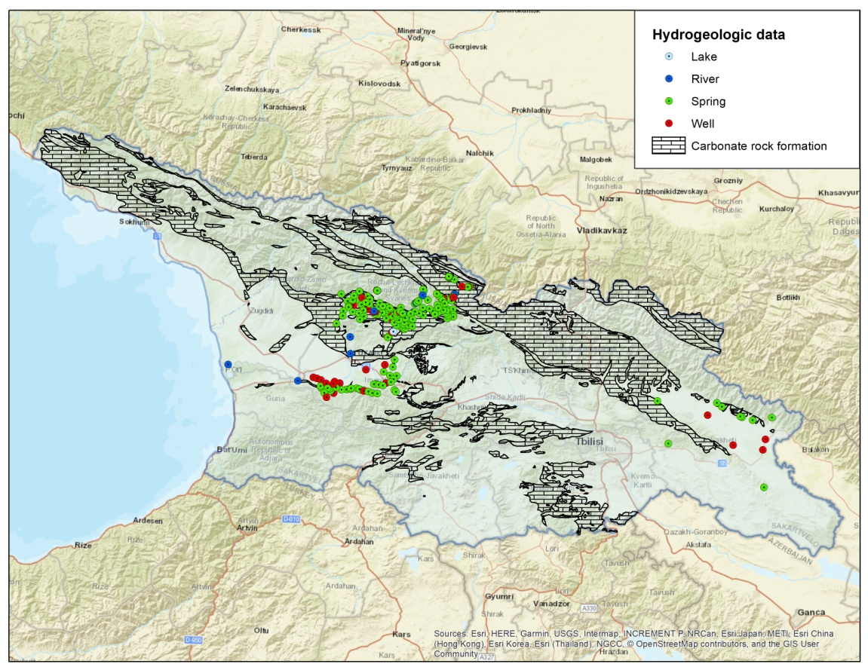
Fig. 1. Distribution of sampling point on the study area

Mapping covered territory of West Georgia. Partially, mountain part of South slope of Great Caucasus Mountain range and part of lowland of West Georgia. Carried out mapping on the territories of karstic areas and the neighbour territories, also. Environmental isotopic (¹⁸O and ²H) analysed and interpreted in laboratory of Institute of Geophysics.

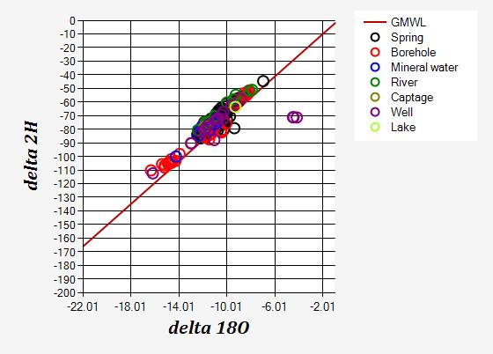
Fig. 2. Isotopic composition of samples.
Fig. 2 shows the ¹⁸O-²H relationship. It reveals that waters in almost all samples are located along the global meteoric water line.
Distributed of stable isotopes are mainly changing between aquifer. Fig. 2 reveals that modern recharge water with δ¹⁸O values more than -8.5 ‰ V-SMOW is fixed in the spring, well, lake and river water at the mountain areas. Boreholes opened deep layer contains normal and mineral groundwater with heavier δ¹⁸O value between -7.5 and -8.5 ‰ V-SMOW. Samples from deep boreholes (Tskaltubo, Vani etc) open thermal water layer contains paleo-waters with δ¹⁸O values between -11 and -13‰ V-SMOW.
In order to study groundwater pathway and mean transit time will be continue mapping process and will be monitoring stable isotope variation in the future

Conclusions
Isotopic composition of water in the study area evolves according to a line parallel with the global meteoric water line. Available isotopic data indicate several groups of groundwater. Some of them represent older waters. The most variable indicate the evolution of groundwater isotopic composition from the recharge area in the mountains through river valley to the filtration areas. Deuterium excess has higher values which are typical for mountain precipitation and snow in other mountain ranges. The conjunctive use of isotopic approaches demonstrates a high potential for future water resources studies in Georgia

References
- Melikadze G., Chelidze T. , Zhukova N., Rozanski K., Dulinski M., Vitvar T. (2009). Using nuclear technology for environmental safety and sustainable development of water resources in Borjomi region (Southern Georgia). Journal of Georgian Geophysical Society, Issue (A), Physics of Solid Earth 13a, 17-25.
- Melikadze G., Chelidze T., Jukova N., Malik P., Vitvar T. (2011). Using Numerical Modeling for Assessment of Pollution Probability of Drinking Water Resources in Borjomi Region (Southern Georgia). In: Climate Change and its Effects on Water Resources, Issues of National and Global Security (Baba A., Tayfur G., Gunduz O., Howard K.W.F., Fridel M.J., Chambel A., eds.), NATO Science Series. Springer. ISBN:978-94-007-1145-7. Chapter 29, 267-275.
- Vitvar, T, Aggarwal, P.K.,Herczeg, A.L.(2007). Global Network is launched to monitor isotopes in rivers. EosTrans. AGU 88:325–326.
- Melikadze G, at al., Preliminary result of stable isotopes monitoring in the Alazani-Iori catchment , Journal of Georgian Geophysical Society, Issue (A), Physics of Solid Earth, v.17a, 2014, pp. 39-46
- G. Melikadze, N. Zhukova, M. Todadze, S. Vepkhvadze, T. Vitvar. "Result of numerical modelling of groundwater resource in the Shiraki catchment”. Journal of Georgian Geophysical Society 01/2014; Physics of Solid Earth, v. 17a (Issue (A)):102-108.

Acknowledgments: The authors thank the Rustaveli National Scientific foundation for financial support of the project #FR-18-18411 "Environmental tracers for assessment of karstic water resources under climate changes in Georgia.

სტაბილური იზოტოპების მეთოდოლოგიის გამოყენება კარსტული წყლების წარმოშობის დადგენის მიზნით

მელიქაძე გ.ი., მალიკი პეტერ, ვეფხვაძე ს.გ., თოდაძე მ. შ., ღლონტი ლ. ე., ჭიკაძე თ. გ.

რეზიუმე
კარსტული წყლების წარმოშობის და გავრცელების დადგენის მიზნით დაწყებული იქნა დასავლეთ საქართველოს ტერიტორიის აგეგმვა სტაბილური იზოტოპების მეთოდოლოგგის გამოყენებით. შესწავლილი იქნა სტაბილური იზოტოპების გავრცელება ტერიტორიაზე, მიწისქვეშა წყლების წარმოშობა, მათი კვებისა და განტვირთვის არეები.

Использование методологий стабильных изотопов для устоновления происхождения карстовых вод

Меликадзе Г. И., Малик Петер Вепхвадзе С.Г., Тодадзе М. Ш, Глонти Л. Е. Чикадзе Т. Г.

Аннотация
Для устоновления происхождения и распространения карстовых вод, былы начати съемочные работы с использованием методики стабильных изотопов, на территорий Западной Грузии. Было изучено распостранение стабыльных изотопов на территорий, происхожение подземных вод ареалы их питания и разгрускиы.

